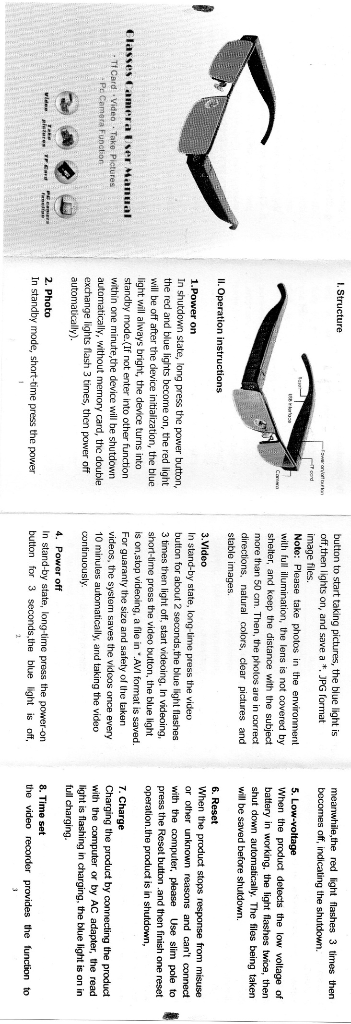

A screenshot of a cell phone

Description generated with high confidence